F-39 -

Functionality
Clearing down payment allows you to post a clearing document manually. This function is similar to transfer posting. You clear a down payment (posted with special GL transaction) and another customer document (e.g. customer invoice).

Scenario
A customer was asked to pay a down payment before the delivery. The down payment was received and posted. Now you need to clear the down payment with a customer invoice.

Requirements
Outstanding customer down payment and customer document (e.g. invoice).

Menu Path | Accounting → Financial Accounting → Accounts Receivable → Document entry→ Down Payment→ F-39- Clearing
Transaction Code | F-39

1. Double click on F-39- Clearing.

Clear Customer Down Payment: Header Data

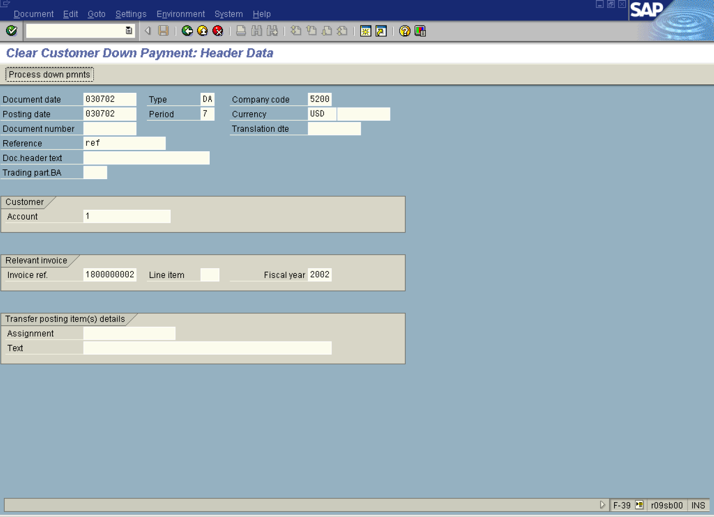

2. Update the following fields:

Field Name | Field Description | Values
Document date | Date the transaction occurred | Example: 030702
Type | Document type | Example: DA
Company code | Code identifying a separate legal entity for which a separate set of accounts is maintained for external reporting purposes | Example: 5200
Posting date | Date that the business transaction occurred | Example: 030702
Currency | Code identifying the type of currency used in a transaction or for all transactions pertaining to a specific account | Example: USD
Reference | Additional document description | Example: ref
Account | Code identifying the Customer account | Example: 1
Invoice ref. | Enter here an invoice number you want clear a down payment with | Example: 1800000002
Fiscal year | Fiscal year number | Example: 2002

Tip: If you don’t know the customer invoice number, you can open another SAP session (Press Create New Session button) and display the customer open items – transaction code FBL5N.

3. Click Process down pmnts Button to process down payments.

Clear Customer Down Payment: Choose down payments

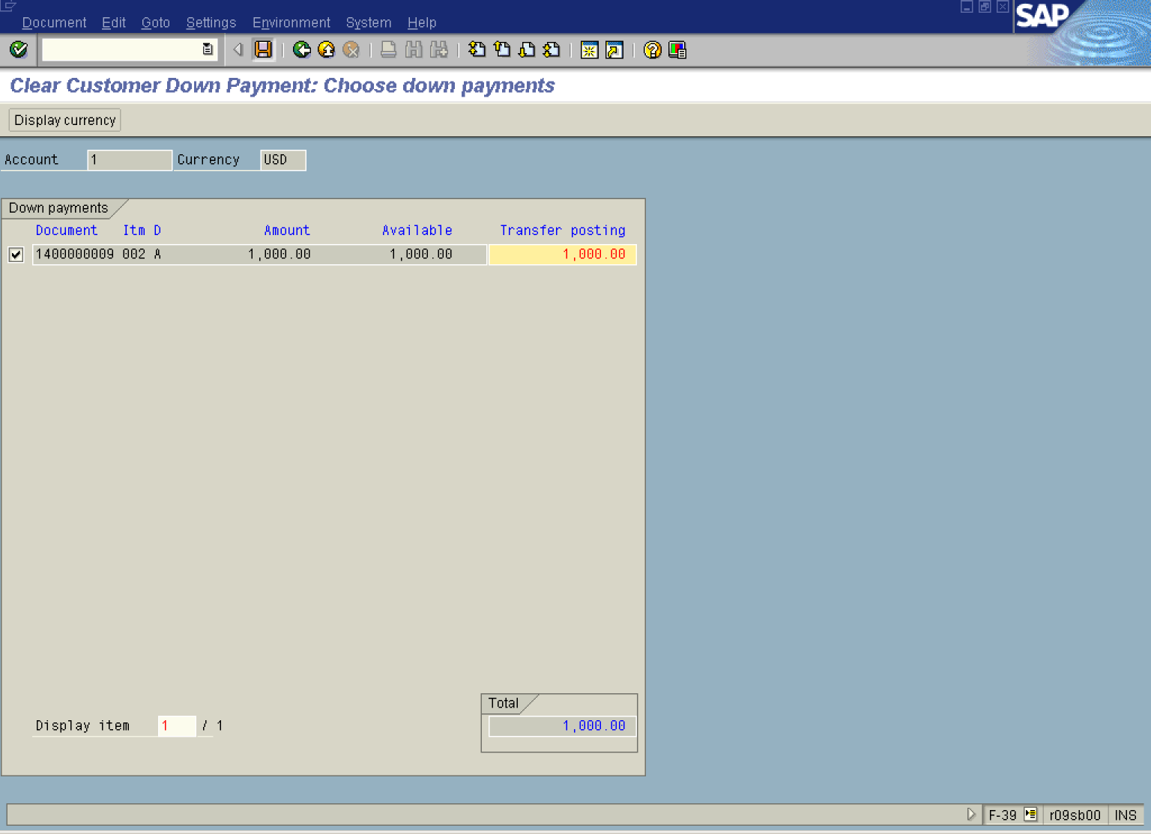

4. The system has displayed a list of outstanding down payments. Click <checkbox> to mark the down payments you want to process.

5. Click Enter Button to confirm your entries. The system will enter an amount of 1.000,- USD in the field “Transfer posting”.

6. Click Save Button to post a clearing document. The system will display a document overview:

Clear Customer Down Payment: Display Overview

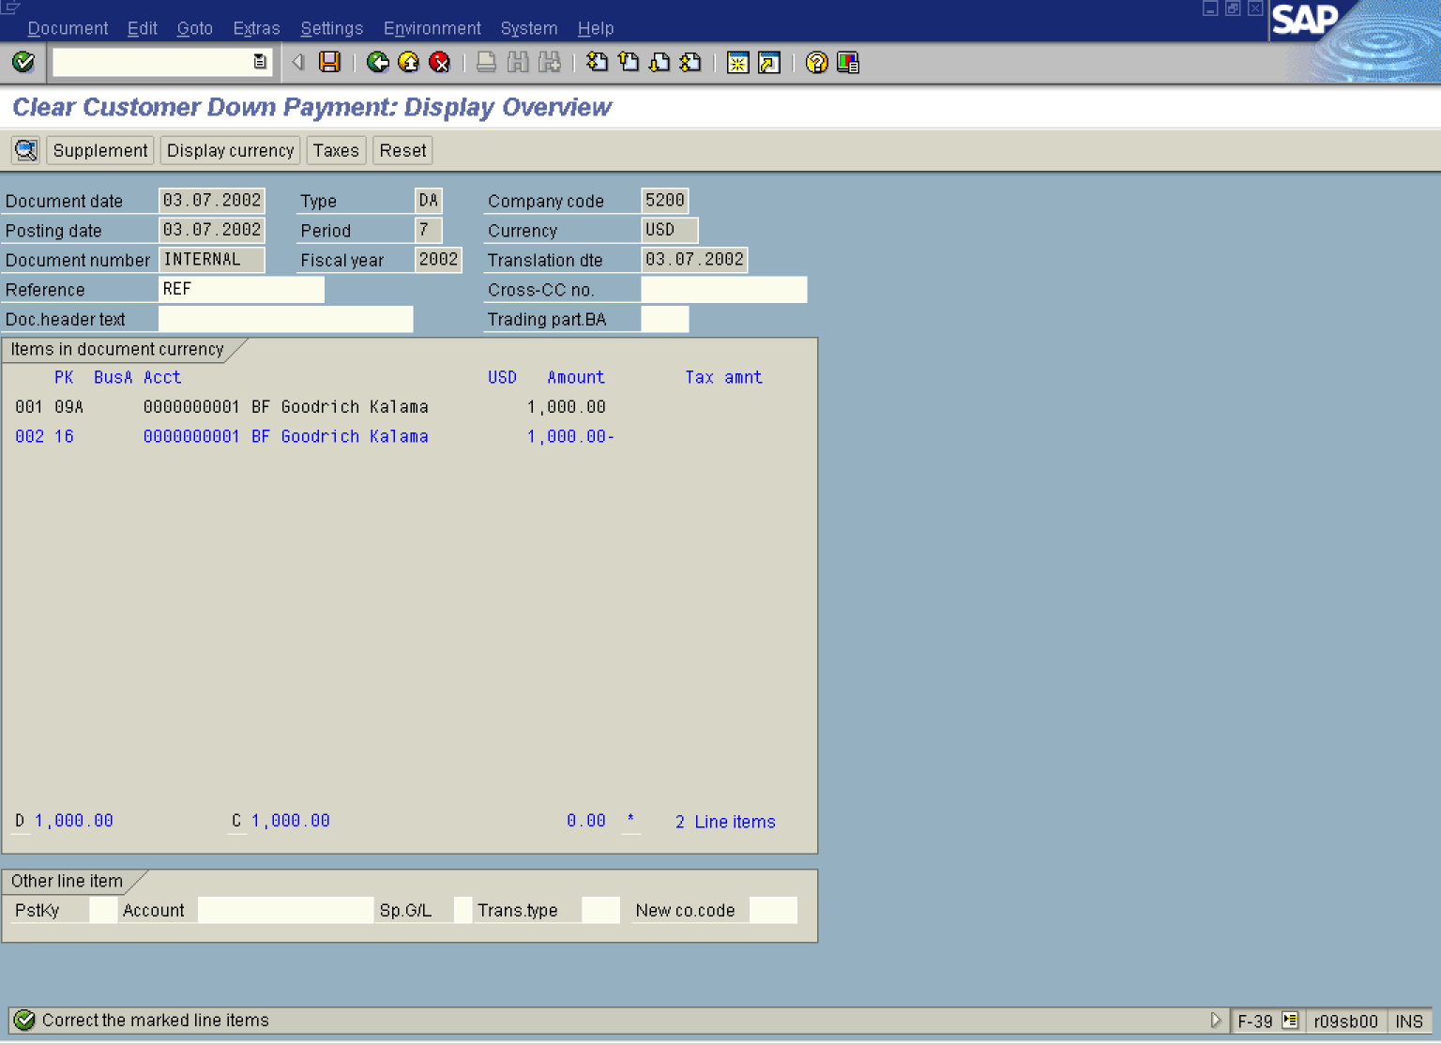

7. The line item 002 is highlighted in blue. Some additional data must be entered. Double click on this line:

Clear Customer Down Payment: Correct Customer item

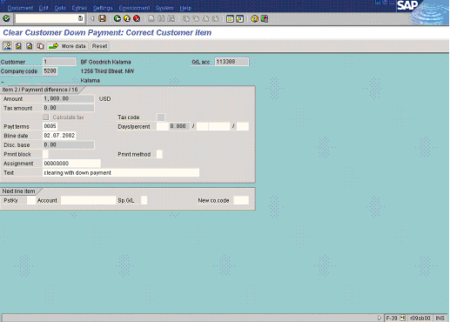

8. Enter document description in the field “Text”.

9. Click Button to display document overview:
Clear Customer Down Payment: Display Overview

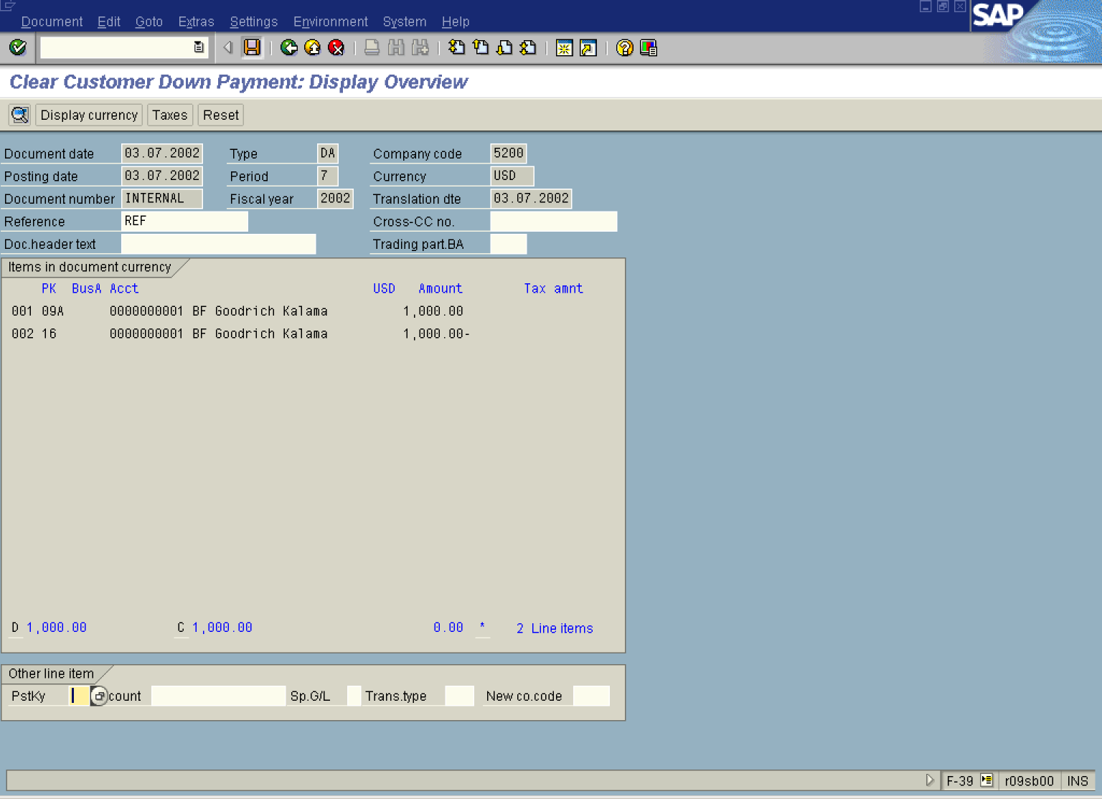

10. Click Save Button. to post down payment clearing.

11. The message bar displays “Document xxxxxxxx was posted in company code 5200”.

 This transaction transfers the down payment balance from special GL account to the main reconciliation account. Further, the down payment is also linked to the invoice.
12. Display customer open items (FBL5N). As you can see, the newly posted clearing document (1600000003) is still outstanding and you need to clear it with the invoice (1800000000002).

